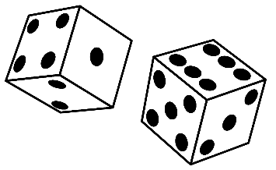
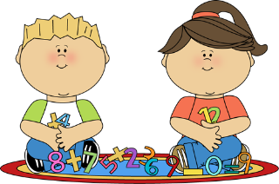
Practical Mental Maths Games
to Play at Home

Playing fun games like these with your child is a great way to develop their mental maths skills.

- Count forwards/backwards in 1s, 2s, 5s, 10s, etc as you walk up/down the stairs, while throwing/kicking/bouncing a ball, bouncing on a trampoline, skipping etc. Remember to start at different numbers!

- Roll one die – what is the number? What is one more/one less?

- Roll two dice, add/subtract the numbers. What is one more/one less than this number?

- Number Bonds to 10 Bowling – set up 10 skittles/milk cartons/yogurt pots. Roll a ball – can you count how many you knocked down? How many more do you need to knock down?

- Number bonds to 10 – pairs/snap – make number cards with numbers 0-10 (or use playing/UNO cards) and play pairs/snap with numbers that add together to make 10.

- Jenga – write addition/subtraction sums on Jenga bricks – when you pull out a brick you must answer the sum or write numbers on Jenga bricks – when you pull out a brick you must say what number you would add to that to make 10.

- Draw out a hopscotch grid on the pavement with chalk and write a different number in each square. Roll a dice to see how many ‘hops’ to make – ask your child a question about the number they land on e.g. what is the number after/before, what is 2 more than that number, can you double that number, how many more would you need to make 10? etc.

